Dipika Mazumdar 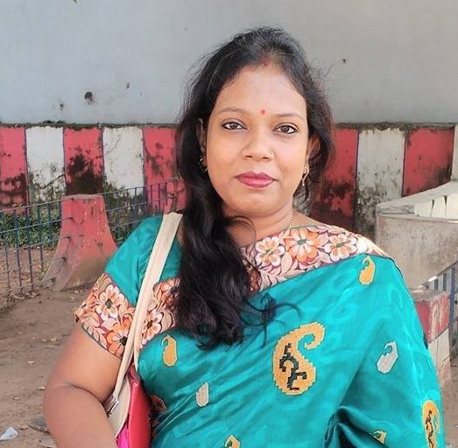
Shibachal More,
East Temple Road,
Holding No. 2, Birati,
Kolkata – 700051.
Mobile: 9836385515 / 9088777503
Email: dipikamazumdar13@yahoo.com / dipikadeymazumdar@yahoo.in

Objective:

► To work in an organization that would provide the best opportunities of
Personal & professional growth.

Professional Experiences: (If any)

► Organization : Purshotam Company Pvt Ltd
Designation : Back Office Service Coordinator.
Duration : From 21st March, 2015 Till Date

► Organization : Mukesh Hyundai
Designation : Customer care Executive Cum Receptionist.
Duration : 11 months

► Organization : D.K.Group Of Companies.
Designation : Customer care Executive cum Receptionist.
Duration : 9 months

► Organization : Domino’s Pizza India Ltd
Designation : Team Member (Gold)
Duration : 1 year & 4 months.

Summer Internship

► Organization : CARRIER AIRCONDITIONING & REFRIGERATION LTD.
Designation : Customer Service Executive, (Trainee)
Duration : 2 months (28.05.2011 – 30.7.2011)

Academic Qualifications:

► Post Graduation: MBA from Camellia School Of Business Management, Under West Bengal University of Technology.1st Semester Marks is 70% (7 points), 2nd Semester Marks is 66.3% (6.63 points), 3rd semester marks is 75% (7.5 points), Final Semester Marks is 71.2% (7.12 points).
► Graduation: Passed B.Com (Hons) from Victoria Institution College under Calcutta University, in the year 2009 with 50% Marks.
► Pre Graduation: Passed ISC from St Paul’s Kg & Day School Kolkata, under Council for the Indian School Certificate Examination, New Delhi in the Year 2006 with 71% Marks.
► Passed ICSE From Mt Carmel Dhanbad, under Council For The Indian School Certificate Examination, New Delhi in the Year 2004 with 66% Marks.

Professional Qualification:

► Passed Financial Accounting Course from Brainware in the year 2007 – 2008.

Personal Details:

Date of Birth: 07/01/1989.
Nationality: Indian.
Marital Status: Married.
Father’s Name: Late D.K. Majumdar
Languages Known: English, Hindi and Bengali
Other interest: Reading books, watching movies, travelling.

Achievement: If Any

►In MAT (Management Aptitude Test) scored 75% marks.
►Received Certificate OF Participation in ERP/SAP Program conducted by
Camellia School of Business Management.

Strengths:

► Strong Will Power
►Excellent communication skill
►Patience
► Team Spirit
► Aptitude For Practical Work.

Declaration:
I hereby declare that all the above given information is true and correct to my knowledge.

Date:

Place: Kolkata

………………………...
Dipika Mazumdar

